America Hanging in the Balance, Satan's Offerings vs. Our Prayers
March 28, 2017

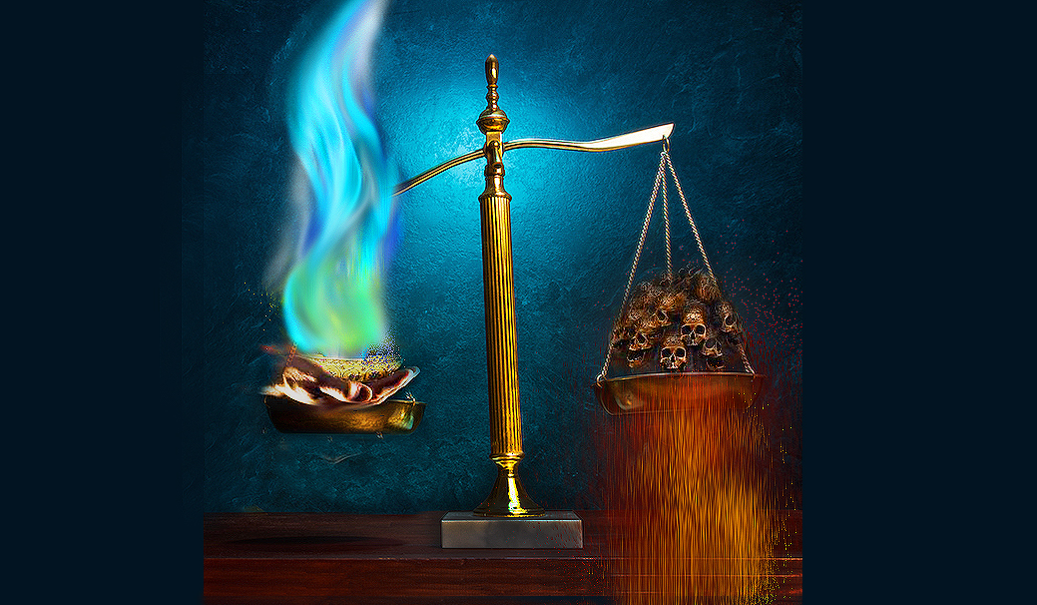
Dear Heartdwellers, it is my prayer that we correspond to the grace the Lord is imparting to us in this message. Lord help us to respond in obedience. And to understand the gravity of this situation.

Well, this is an update on the state of affairs in our nation, spiritually. I have carried America in my heart today, crying out at different times for the mercy we so desperately need, especially as I prayed the Divine Mercy Chaplet.

Jesus began, “I have seen your tears and heard your cries for mercy, yet the outcome is undetermined. However, if all My people will apply their hearts to this kind of prayer I will be able to turn the tide."

And just to be clear on this point, I didn't spend hours and hours in prayer. I spent probably an hour and a half with the communion service and then praying the Divine Mercy chaplet, altogether. But they were strong, heart-felt prayers and they were anointed. And the Lord gave me the gift of tears of praying for our nation. So, this is not a huge dedication of time that He's talking about here. This is doable.

Jesus continued, "But My Love, not everyone is listening and caring enough to join in. They have no idea of what horrors await them if these disasters are not averted by prayer. So I want you to continue to call all to repentance and fasting. Repent for the times you didn’t go to prayer; deny yourselves for the times you didn’t pay heed. Apply your hearts to the prayers and perhaps this evil event planned can be circumvented. If enough hearken to My plea, there will be mercy.

"My people, this is the time to rend your hearts on behalf of America. The very evil underground government also has underground armies, mighty and fearless, bold and without a conscience, shoulder to shoulder, none breaking ranks. Woe to those they fall upon."

And as an aside on that, I've been having an understanding - I keep seeing black military uniforms. And I've been having an understanding that the U.S. Military is not the only army on American soil. I keep having flashbacks to the NWO military in the Left Behind movie. Black uniforms. U.N. Ruthless, with full authority. Authority even over all of our forces in America.

And this evening we gathered together for prayer and one of our number was shown the scales of justice in Heaven and the angels were placing our prayers and sacrifices on the right side of the scale, which was just a little lower than the left side. The other side were also things weighing it down and she asked, “What are those?” And the answer that was given was that it was curses, spells, wicked deeds, offerings to Satan, by his worshipers.

As she looked at the scales, the left side was just a tad above the right side, but barely. The Lord said to her, “Pray, My children, pray. Sacrifice and give as much as you can, for we need to keep the balance tilted to the right.” And it was understood that the servants of Satan were praying and sacrificing almost as much as the servants of Our Lord Jesus.

People, that shouldn’t be! We need to tip those scales off the charts to get the promised two years before the Lord’s next review. The Satanists fast and pray curses on others to please Satan. We need to fast and pray blessings, healing and deliverance to counteract their wickedness.

There is still hope, but our dedication to prayer must outweigh the Satanic covens who cast spells and curses to bring chaos on the world, division among Christians and moral decline. The future is in our praying hands. Antichrist is here, but he can do nothing until the Church is removed. That’s because our prayers are POWERFUL and he is still being bound until the appointed time.

The appointed time is in our praying hands.

I am not able to do a lot in fasting, but I can keep a reign on my heart and mouth, and not allow my judgmental thoughts. I can give up desserts and other small things.

But I do carry the United States in my heart and frequently cry out to the Lord, “Mercy over our country, Lord, mercy!” That heart cry is heard all the way to the Throne. I pray other prayers as well, but that simple cry does add weight to our side of the scales of justice. It comes from my heart.

And those of you who are praying from your heart, that is a powerful prayer. Carry America and the world in your hearts, Heartdwellers. Carry her and cry out over her as well as praying in the spirit and with understanding.

The Lord continued, "Your country is precariously teetering because of the wickedness of certain key members of your government. However, I am still with Donald and as long as you pray, change will come. Not as much as I would like to see right now, but still - it is some progress. Oh, how I need more, more, more from all of you.

"My people, the more you pray and offer sacrifices, the more joy you will experience as you see your government turned from evil to good. The more secure your life and ministries will be. The more productive and fruitful your lives, your children’s lives and the lives of those around you. But I am calling you to really deny yourselves, pick up your cross and follow Me into the battleground of prayer. This is a time for 'all hands' to be on deck! In other words, each one of you are critically needed to turn this monster.

"None among you are too little, too small or insignificant that your prayers don’t matter. Every child’s prayers, every senior's prayers, every disabled person's prayers are needed. You who suffer with sicknesses that I have not yet healed, have great weapons in your hands as you offer your daily inconveniences, embarrassment and pain. That is a very great influence.

"I am calling upon every Sunday school teacher, pastor, counselor, nurse and those in positions of influence to put the word out. Pray for peace to come to America. Pray for an end to the political posturing and using Americans for personal agendas. Pray the eyes of all will be opened to how destructive this bickering is. Pray your president will be respected so he can move forward with the reforms I have given him. Pray the evil persons in government will be exposed and brought to justice.

"Pray for the disarming of the lying press that is continually shaping people's minds. Pray for those minds to start operating on their own, not under the spell of the media. For that is TRULY what has happened. “The media is under a spell by the forces of darkness to deliberately mislead and sabotage your nation. Pray that this spell be broken and people wake up and start thinking for themselves.

"Pray all these things with passion from your hearts and you WILL see change. Break the curses off your government controlled by Satan. Thousands of innocent children have been victimized, brutally raped and tortured as offerings to Satan to bring this nation down.

"Offer blessings, prayers, vigils, kind deeds, works of Mercy and especially informing the ignorant to offset this plague of evil that determines the destiny for you and your children. This is what is needed now. I am calling all of you, from the oldest to the youngest, to storm Heaven on behalf of your nation.

"Then, I promise you, you will see change. This is the time to rally. All hands on deck! Then you will see change."

